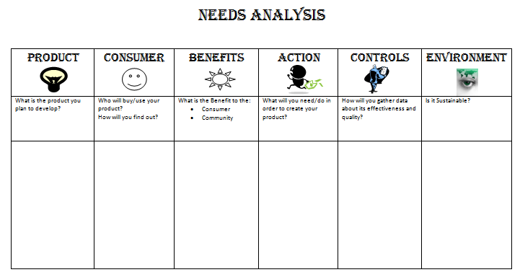

Identifying a need for an innovative Future product or service

***Think, pair, share ideas for identifying a new product or service to the community***

Product idea: Name(s): g