Current international trade practices and policies are set and controlled by a handful of big corporations and contribute to intense poverty, environmental degradation, rural unemployment, and overall inequality in the world.
These trade rules, agreed at the international level, favour the wealthiest nations and their business interests. Transnational companies exploiting cheap labor around the globe are seriously under regulated, leading to abuse of human rights and the environment.
No matter how hard people work, almost half the world’s population currently lives on under $2.50 a day.
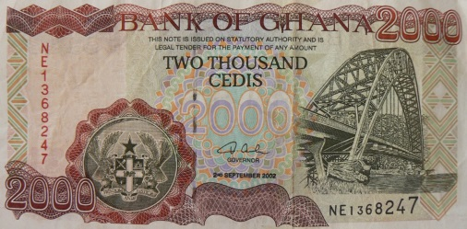
In Ghana (a producer of chocolate) the daily wage for an average worker is 6 Cedi. One Cedi is equal to about 25c Australian
Fair trade sets out to create better trading conditions for farmers and workers in poor countries. This social movement started in the late 1940’s and seeks to address this inequity. With better working conditions and prices for their goods and less negative environmental impact people have a chance to improve their lives: feed themselves, send their children to school, and meet their basic needs which are the right of every person on this planet.

Goal

Students will make a connection between hunger, poverty, and non-living wages; they will understand the concept of Fair Trade and what the differences are between products that have a Fair Trade label and those that don’t. They will also learn that there are things they can do here at home that can make a difference in people’s lives in other countries.
Concepts/Skills
Stage 1: Desired Results mental
Fairness. Justice. Living wages. Conscious choices/action.
What power do we have as consumers? What are our responsibilities as consumers?

Australian Curriculum

Develop questions to guide an investigation of an economic or business issue or event, and gather data and information from observation, print and online sources.

The effect that consumer and financial decisions can have on the individual, the broader community and the environment

Investigating questions such as ‘Does what my family buys in the supermarket affect what businesses might sell or produce?’

Investigating how consumers rely on businesses to meet their needs and wants

Examining how businesses respond to the demands of consumers, for example preference for healthy options, environmentally friendly packaging or organic food

The ways consumers and producers respond to and influence each other in the market

Exploring why businesses might set a certain price for a product (for example, because that’s what they think consumers will pay) and how they might adjust the price according to demand.

Considering how consumers might influence producers in other countries, such as those in the Asia region, to provide goods and services

Background knowledge

That as consumers we have the power to help improve peoples’ lives in faraway places by buying products that are certified Fair Trade. To think critically when it comes to taking care of our own needs.
Students may have a basic understanding of world geography.

Student Groupings

Whole class.
Groups of three or two.

Cross curricular
Literacy skills
Oral language through discussion, brainstorming ideas
Reading aloud, skimming, comprehension
writing notes, writing a personal opinion, creating a persuasive text.
Numeracy skills Placing facts along a number line.
Geography identifying features of Africa
Sustainability
Critical thinking Deductions and conclusions.
Materials
Access to IT
poster paper/large sheets, post-its
Map of Africa -showing environmental aspects like rainfall, deserts, equator http://www.catsg.org/cheetah/07_map-centre/7_1_entire-range/basic-maps/africa_vegetation.gif
Numberlines that show percentage/fractions
Fairtrade chocolate packaging

Websites
http://facts-about-chocolate.com/fair-trade-chocolate/
http://www.fairtrade.net/cocoa.html
http://www.fairtrade.org.uk/en/buying-fairtrade/chocolate
http://youtu.be/mk9b3jbJroM
https://www.youtube.com/watch?v=Z8vlbXDOXUU#t=79 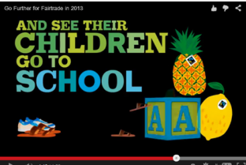
Considerations

Find out who might be allergic to substances found in chocolate.
Cultural/religious sensitivities.
Inquiry question
Should Australians ban, accept or promote Fair trade chocolate? (5 MINS.)
Have a brief discussion about chocolate. How to you choose the chocolate that you buy? What influences you?
Students use the internet to research fair trade and chocolate. Collect notes. Create diagrams if necessary. (50 minutes)
On a map of Africa mark the countries that grow cocoa beans. What kind of climate do they need to grow? Look up some population and economic facts about these countries.
In pairs - sort the information.
What are 5 of the most interesting words you came across and what do they mean ?
Five of the most interesting math facts so far?
Place your interesting math facts using the number line.
Questions unanswered, opinion so far.
In small groups read a text about how chocolate is created. Students add the new information to their notes.
View some Media clips about Fair Trade. Look at the Fair Trade logo. Students will need to add new information to their notes.
View a clip about how Australia went into the chocolate market.
http://www.abc.net.au/landline/content/2012/s3526983.htm 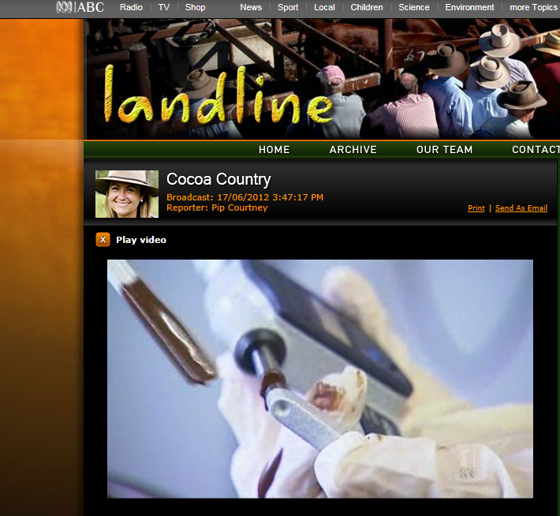

Game
Play the Banana-split game.
http://www.cafod.org.uk/Education/Primary-schools/Fair-trade
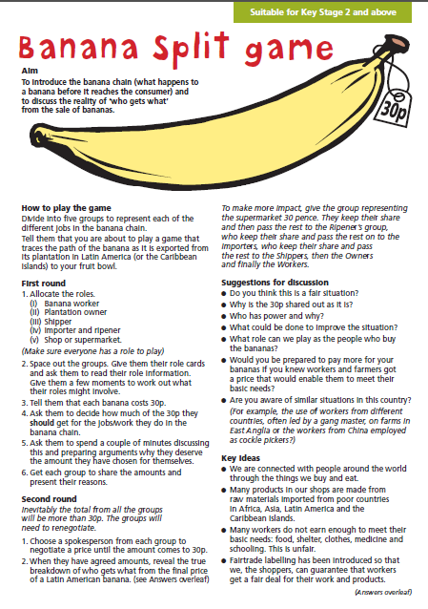
Activity
Using the information gathered students can show what they have learnt through choices such as pamphlet to give customers at a Fair Trade stall, a video to explain what Fair Trade chocolate is or use a box to create packaging for Fair Trade chocolate.
Students will be involved in self assessing their marketing of the Fair Trade product by using the following criteria.
AUTHOR | Who would be making this? Is it recorded ?
CREDIBILITY | What sources of information are you using? Why were they chosen?
CONTEXT | Where or how would this shared with my audience?
INTER-PRETATIONS | How might different people understand this message differently?
TECHNIQUES | What production techniques have been used?
IMPACT | Who might benefit from this product/brochure/media (and how)?  Who might be harmed by it (and how)?
RESPONSE | What kind of thinking/emotional response do you want your audience to have?
CONTENT | What ideas, values, information, and/or points of view are explicit? Implied?  What is left out of this message and why (and how will that affect the message)?
PURPOSE | Who is the target audience, and what would you need to do in order to reach them?
ECONOMICS | Who could be sponsoring or paying for this?  In what ways do funding sources affect the product ?

Discussions now need to be steered towards the focus on work and trade, and conclusions will be drawn on the relationship between cheap labour/exploitation of labour and inability to meet needs i.e. poverty.
Check for understanding. Create a class definition for what Fair Trade is.
Closing discussion of what students have learned (I will ask questions and ask for feedback from students on their peers responses). Then I will make a demonstration with two blocks of chocolate, one certified organic and Fair Trade, and the other conventional, and ask students if they can tell the difference between the two. This will draw attention to the labelling and recognition of the Fairtrade symbol and the need to see that to be certain the product we buy is indeed, Fair Trade there has to be that label. Make the point together, that our actions here can have a positive or negative affect on people’s lives very far away; that we can make a difference.
Extension
To tie into the writing strand of the Language curriculum students could do the following assignments that would require them to “generate, gather, and organize ideas and information to write for an intended purpose and audience”:
Do an analysis and comparison of organic versus conventional farming and defend how one is more sustainable than the other. Why is consumer demand for organic food increasing?
Learn about cooperatives then compare and contrast this to for profit-only businesses.
Do a critical analysis of the role of the World Trade Organization, World Bank, and International Monetary Fund and the pros and cons of free trade. Who is benefitting? Who isn’t?
Is hunger caused by a scarcity of food, or a lack of democracy? Who controls the world’s food supply, and how?
Over one million diamond diggers in Africa earn less than $1.00 a day. What is the Kimberley Process, and how, if at all, has it addressed this extreme exploitation of workers? What improvements have been made since?
http://shop.daintreeestates.com visit this website and compare how Australian farmers produce their chocolate.

Assessment

Describe the effects of consumer and financial decisions on themselves, others and the environment.
Can describe the relationship between poverty and exploitation, and to find strategies for how we can make a difference in people’s lives by being aware as consumers of the things we buy.

Teacher Reflection

How did students respond ?
Could students understand the idea of food availability ?
Can they independently give an opinion on what is fair / what is injustice with some empathy to those in poverty?
Can students describe cause and effect ?
Can students identify how they can be empowered to change a situation ?

